RC tutorial 006 Making cable ducts by offsetting a track  
=============================================

Revised 2019-12-19

* This tutorial's goal is to teach you how to offset a track and produce cable duct alignments.
* Assumed skills: Basic Lua programming, 3D, alignments and the RC alignment manager.
* Assumed Railway skills: Tracks, cable ducts, cant (superelevation)
* Time to spend here: Expert: 20 minutes. Intermediate: 45 minutes. Beginner: 1,5 hour.
* Notice to users with non-English versions of AutoCAD – see footnote[1].
* This tutorial was prepared using software release 2019.1.1492 with Norwegian DNA version “NO-BN 2019.1 beta(c)”,”NO-BN;NO-0001;2019-09-28T20:19:00+01:00;2019.1”.
* Note: If you are using AutoCAD version 2017 or older, then open the 2013-format version of the tutorial DWG file.

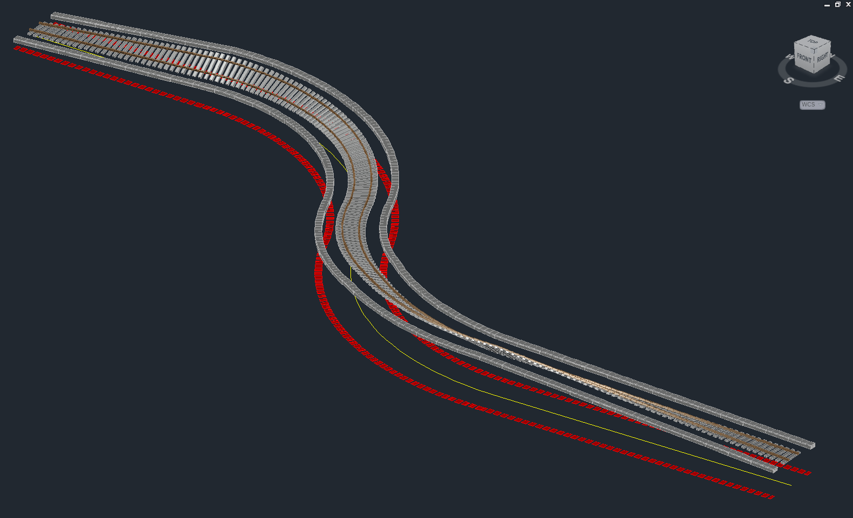

1. Start AutoCAD with RailCOMPLETE, then open the ‘General Tutorials’ folder and locate the DWG file named after this tutorial. You can either type RC-ShowGeneralTutorials or you can locate the button below the RC logo in the upper left corner of your AutoCAD window.
2. Select both duct alignments and active the RC-Show3dPreview tool  to see the tutorial example:  
     
     
   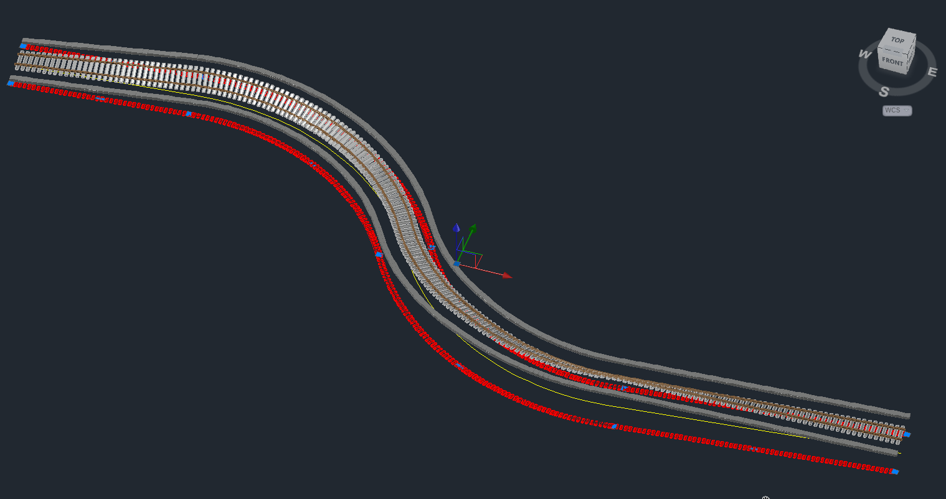
3. You will now be guided through the process of duplicating the example that is already in the tutorial DWG file.

## Creating a track

1. Make sure that CAD editor shows modelspace with a TOP view perspective. Use the NAVVCUBE command to activate the 3D navigation helper:

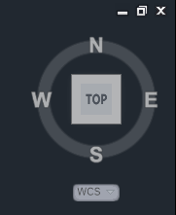

1. Create an alignment of type ‘Railway track’ with at least one curve and a counter-directed curve, with a straight segment at each end. See other tutorials on how to draw a track from scratch using RC-CreateAlignment. You will find it under the Norwegian name of “Alignments\Overbygning\Spor\Normalspor 1435 mm”:  
     
   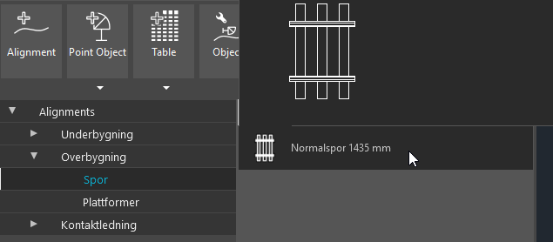  
     
   By the way, ‘Normalspor 1435’ is Norwegian variant name for normal gauge railway track, and ‘KO-SPO Spor’ is the corresponding RC type that you will see in many of the available tools.  
   It might look like this (using RC-ShowAlignmentGeometry and RC-ShowAlignmentMileage to show annotations):  
     
   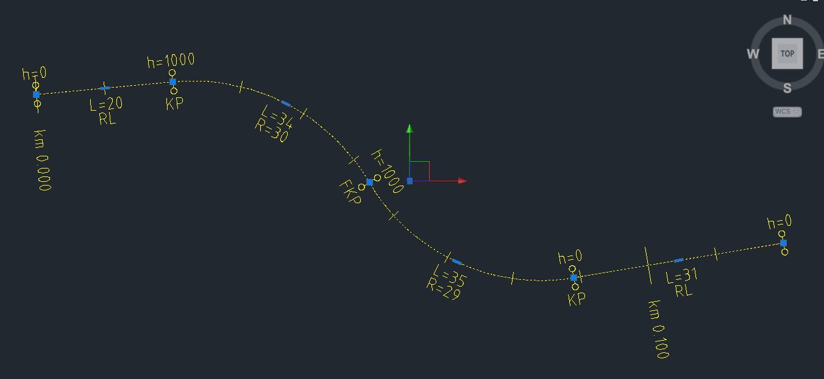  
     
   and  
     
   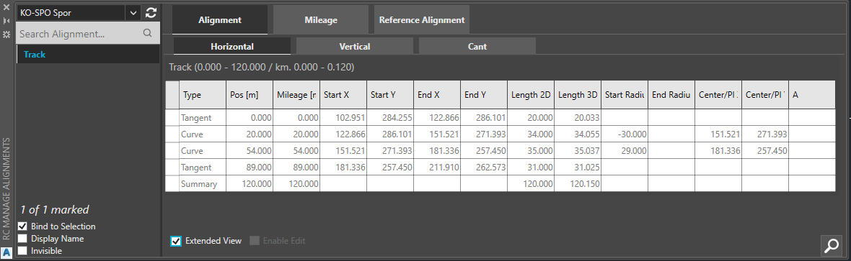
2. Open the RC-AlignmentManager tool   
     
     
   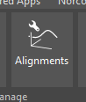  
   and locate the Alignment\Vertical tab. Activate the Enable Edit checkbox at the bottom line and enter a PVI (point of vertical intersection) elevation at each end of your alignment’s vertical profile. In the caption row above the datagrid below you can see “Spor (0.000 – 120)” which means that the geometry of the alignment (the flat line in the XY plane) starts at Pos=0 and ends at Pos=120.   
     
   Enter the three rows seen below by typing a position in the empty square at the bottom of the Pos column, and then modify the Elevation and possibly the Radius columns as well:  
     
     
   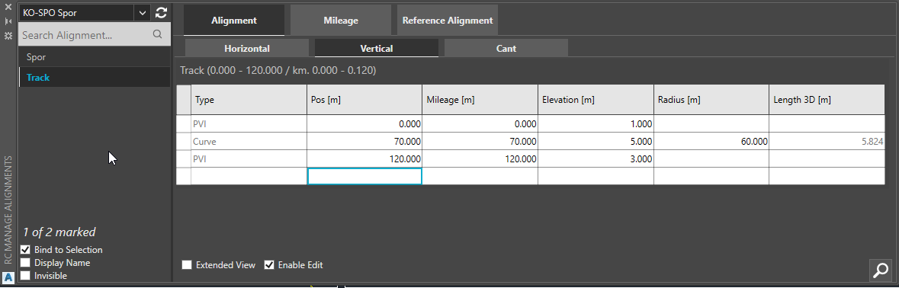  
   Each PVI corresponds to an abrupt change of gradient. Enter a radius of 60 meter at Pos=70, to smoothen the crest (summit) of the vertical profile with a vertical circular arc:  
     
   Before / after smoothing:  
   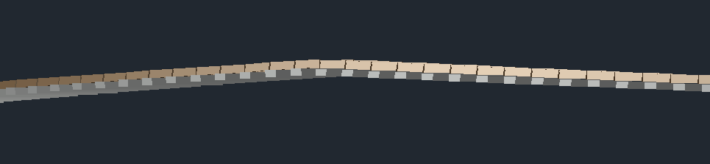 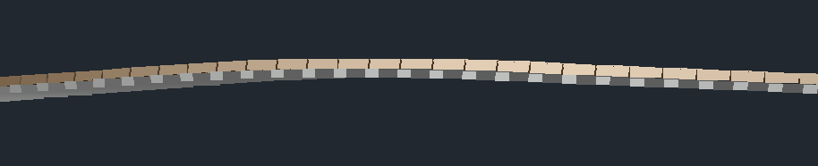  
     
   The vertical profile annotation should look like this (using RC-ShowAlignmentProfile):  
     
   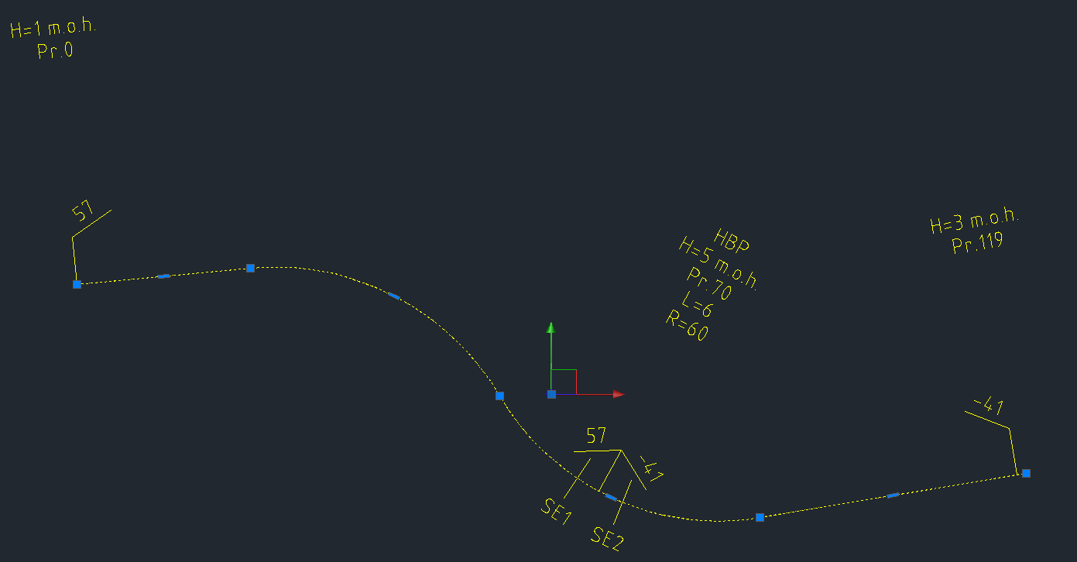
3. Now, we will add *cant* to the track. Cant means to take something which is horizontal and make it inclined. In our case, we will cant the sleepers in curves in order to allow traveling at higher speeds without compromising passenger comfort.  
     
   First, open the Alignment\Horizontal tab and enable Extended View (checkbox at the bottom). Mark the cells in the Pos column and press Ctrl+C (copy to clipboard).   
     
   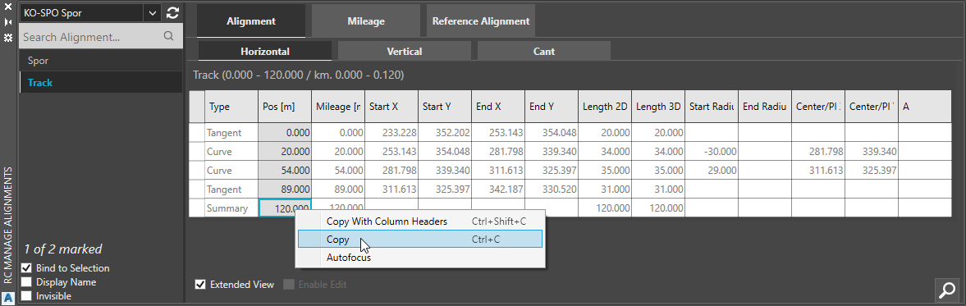
4. Then switch to the Alignment\Cant tab and check ‘Enable Edit’. Place your cursor in the bottom cell in the Pos column and enter ‘0’ enough times that you now have as many rows as you found in the horizontal geometry tab. Mark all non-empty cells in the Pos column and press Ctrl+V (paste from clipboard).  
     
   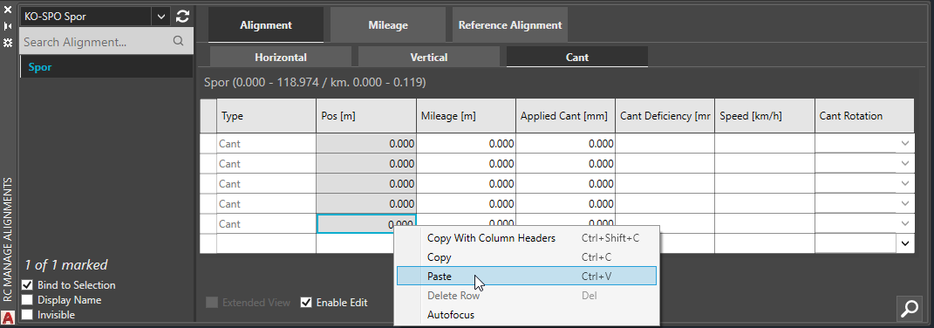  
     
   You now have cant vertices positioned at every position where geometry changes:  
     
   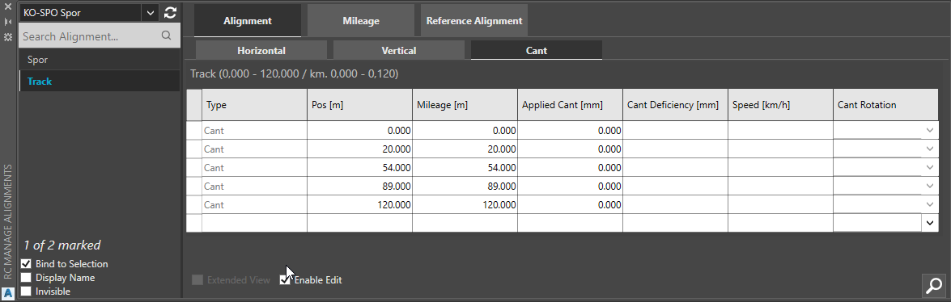
5. Enter an exaggerated cant value for each curve, for instance 1000 millimeters, and make sure that you cant to the right side – Clockwise in right curves (seen in the direction of increasing mileage):  
     
   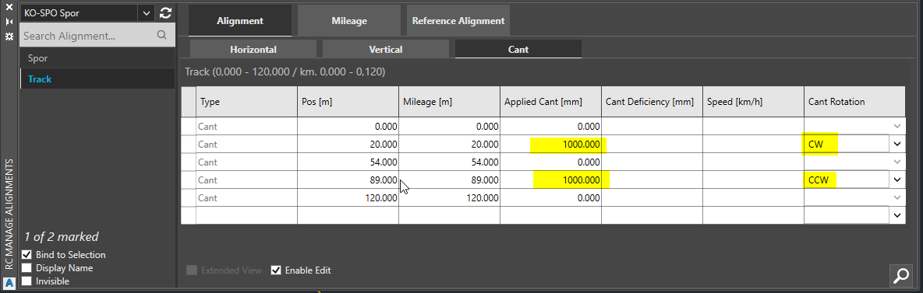  
     
   Activate RC-Show3DPreview and select the alignment to see it in 3D.  
    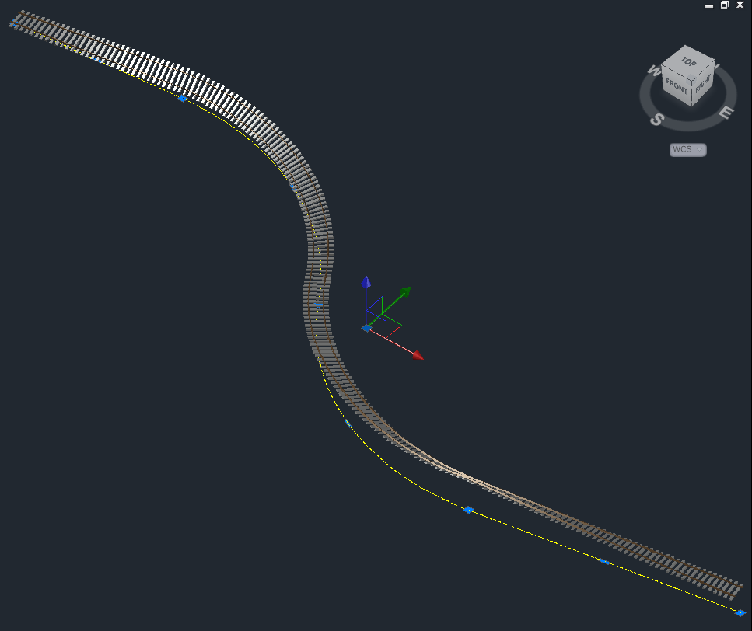  
     
   You can at any time “freeze” the 3D preview of the alignment by right-clicking and selecting “RailCOMPLETE Annotation => Copy annotations to drawing”, which creates a ‘dead’ CAD entity (a block) representing your object in 3D.

## Creating cable ducts from a track

1. This section explains how to create cable ducts from a track. You can specify a positive horizontal offset and select side, and you can specify the Zoffset as a positive or negative vertical offset.  
     
   Start the RC-CreateAlignment command with one of the available cable duct types:  
     
   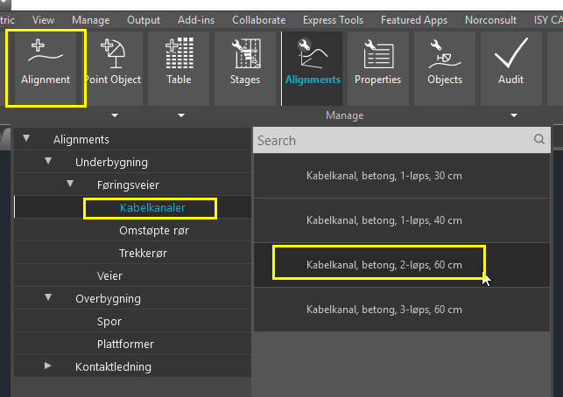  
   Instead of drawing it, select ‘O’ or press the down-arrow and select ‘Offset’:   
     
   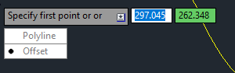
2. Enter 2.85 as sideways Offset, -0.35 as vertical Zoffset, do not Erase the track that we’re going to offset, and let the new alignment’s default layer be used as a Source for the new alignment’s layer (instead of just putting it on the current CAD layer). Make one offset to each side of the track.  
     
   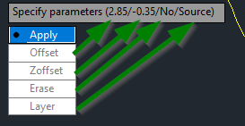  
   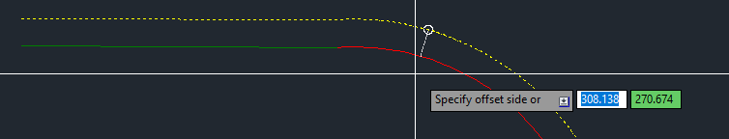
3. A 3D preview of the track-with-elevation and the two offset cable ducts should now look like the illustration shown below. Note that the general elevation of both ducts follows the elevation of the highest rail, both ducts are lifted whenever the railway track has cant (superelevation in one rail).  
     
   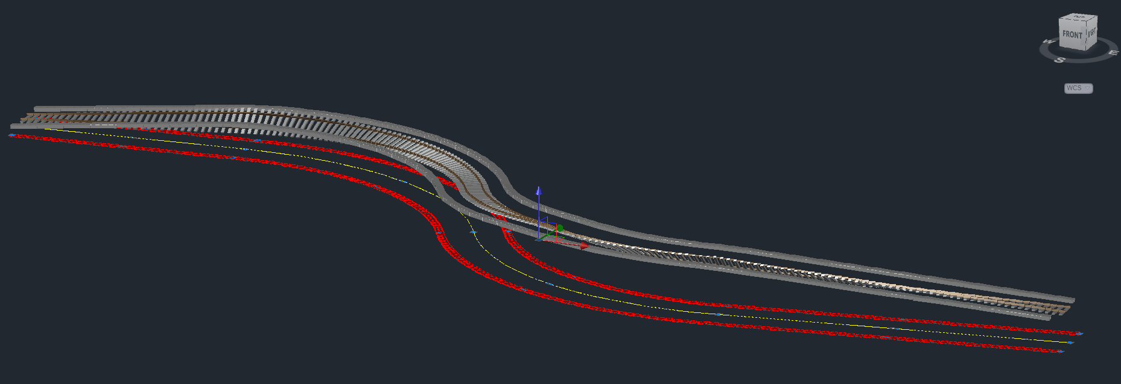  
     
   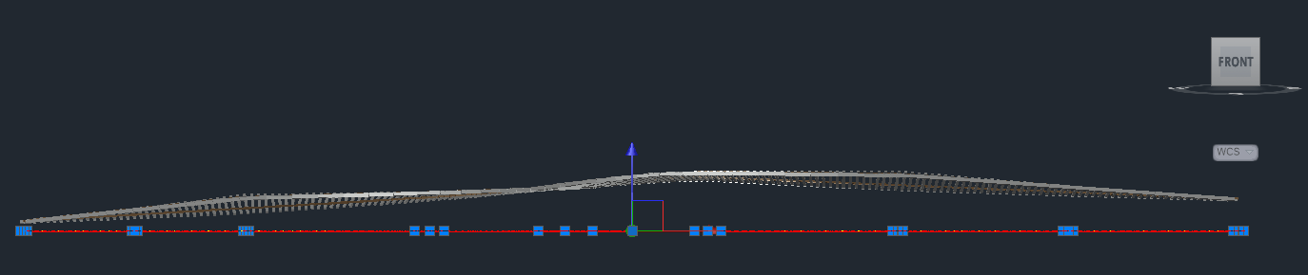
4. If you need to change the type of cable duct, just open RC-ManageProperties and change Variant. Line type and 3D model etc will change accordingly.
5. If you alter the track alignment, then you must repeat the production of cable ducts again.
6. If you need to offset the cable duct vertically or horizontally or both, then you can offset (i.e. using itself as a basis):  
   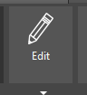 then  and 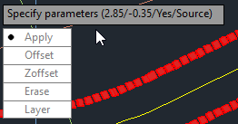  
     
   Erase the base alignment after offset (the GUID will be preserved):  
     
   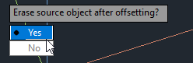

## Cleaning up – removing “junk cant” from the cable ducts

1. Orient your drawing so that you now for sure where the Pos=0 ends are. Use the RC-Position tool to find out:  
     
   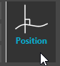  
     
   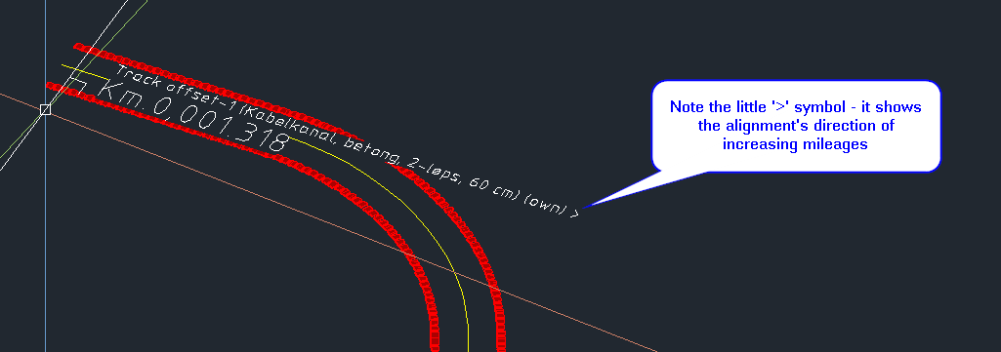
2. Since we want to level each cable duct with the its closest rail, we must *remove* the cant information copied from the track in the ducts whenever the duct is located in inner curves but leave that extra lift in outer curves.
3. To see all your alignments in the Alignment Manager, adjust the filter setting in the top left corner:  
     
   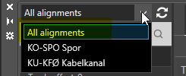
4. Check the ‘Bind to selection’ box and select the track and the two ducts that you have created, then delete ‘junk cant’ data from the two ducts:  
     
   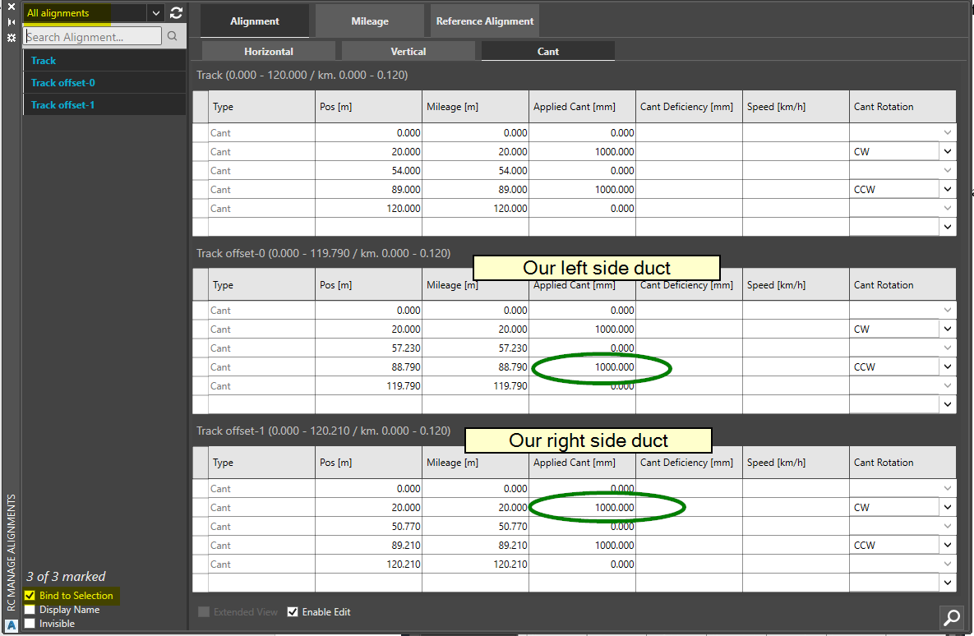
5. You should now see the final result. Note that the three alignments’ geometry lengths are not the same, due to the offset process.  
     
   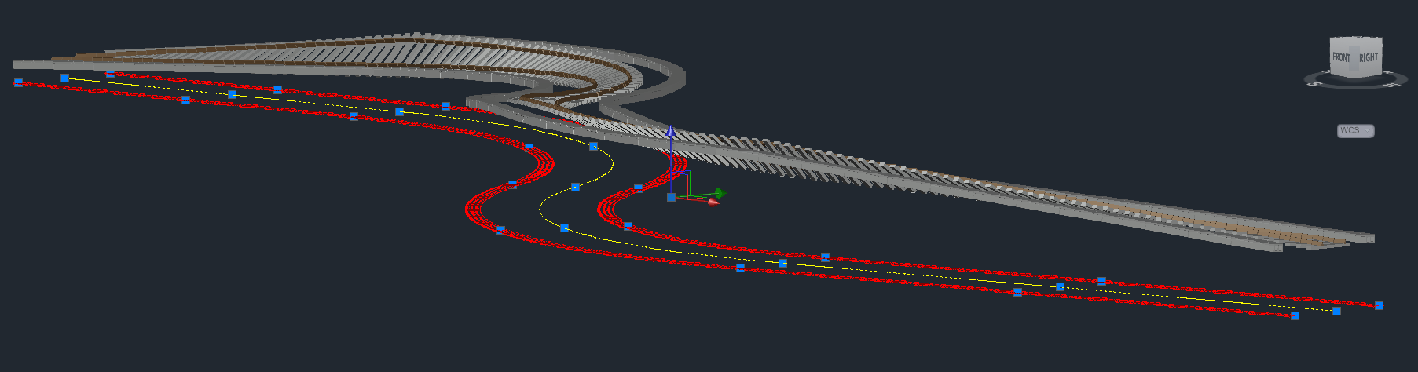  
     
   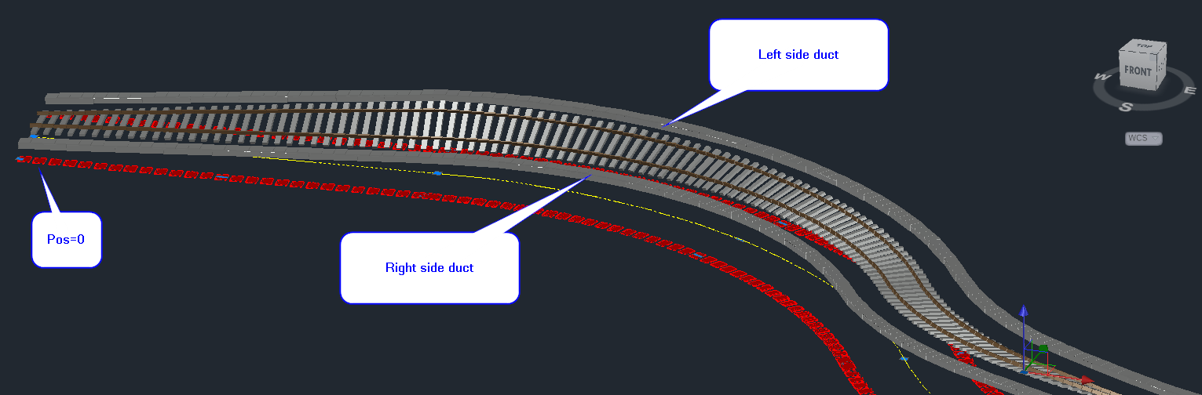  
     
   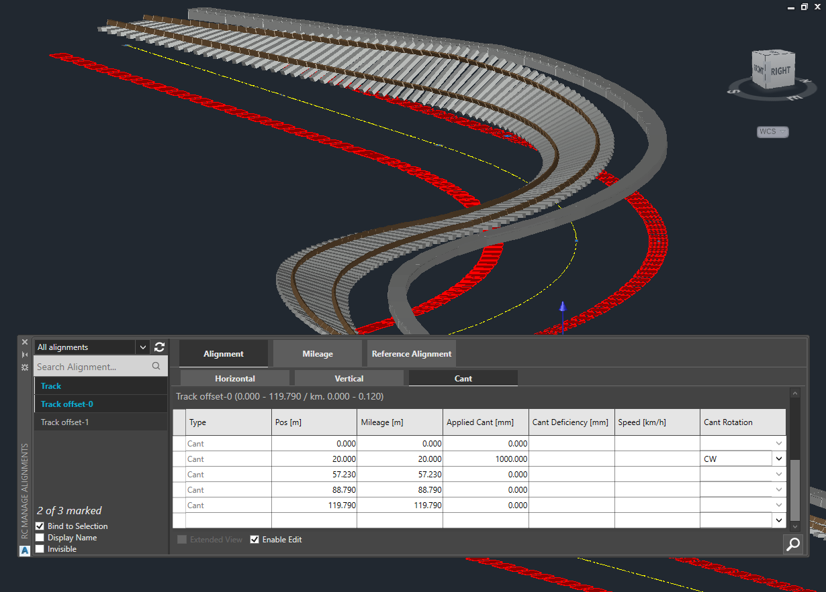

## Survey line construction for digging the gravel bed before placing the cable duct

1. **Note**: The values entered as ‘Cant’ in the duct alignments are not actually used to represent cant as in railway tracks, but it is just a convenient place to store the info about lifting of the cable duct. The embedded Lua formulas for lift (Offset3D.Z) and pitch (Rotation3D.X) use this ‘cant’ info to produce the intended 3D representation of the ducts.
2. We will now produce a 3D line for surveying purposes. The reference shall be the centerline at the bottom of the cable duct concrete elements. The wanted survey line is the sum of the elevation of the duct (the alignment axis) and the added ‘cant’ effect due to lift with closest rail.
3. Open the RC-Export3D tool and locate the Alignment tab:  
     
   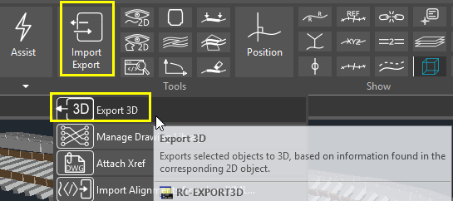  
     
   Check the “Model Insertion Axis” and Save then Cancel:  
     
   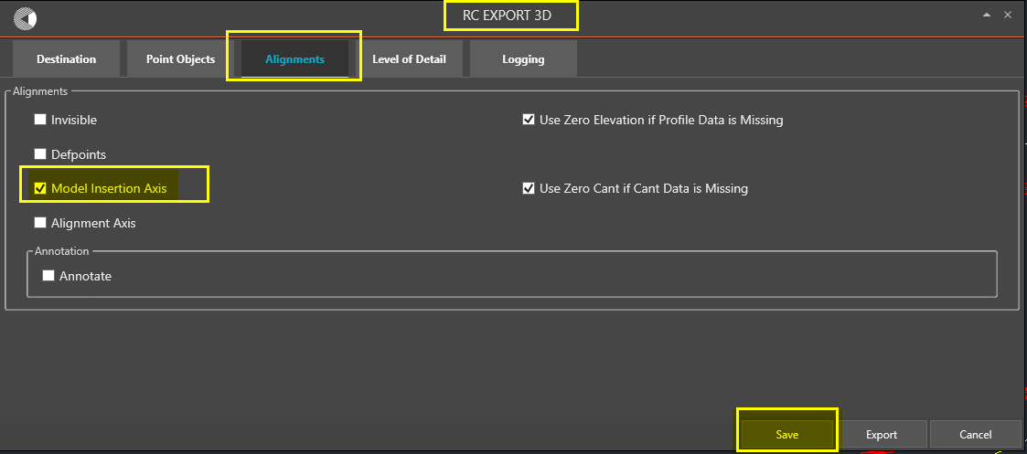
4. Watch the survey lines as you select the ducts (with active 3D preview):  
     
   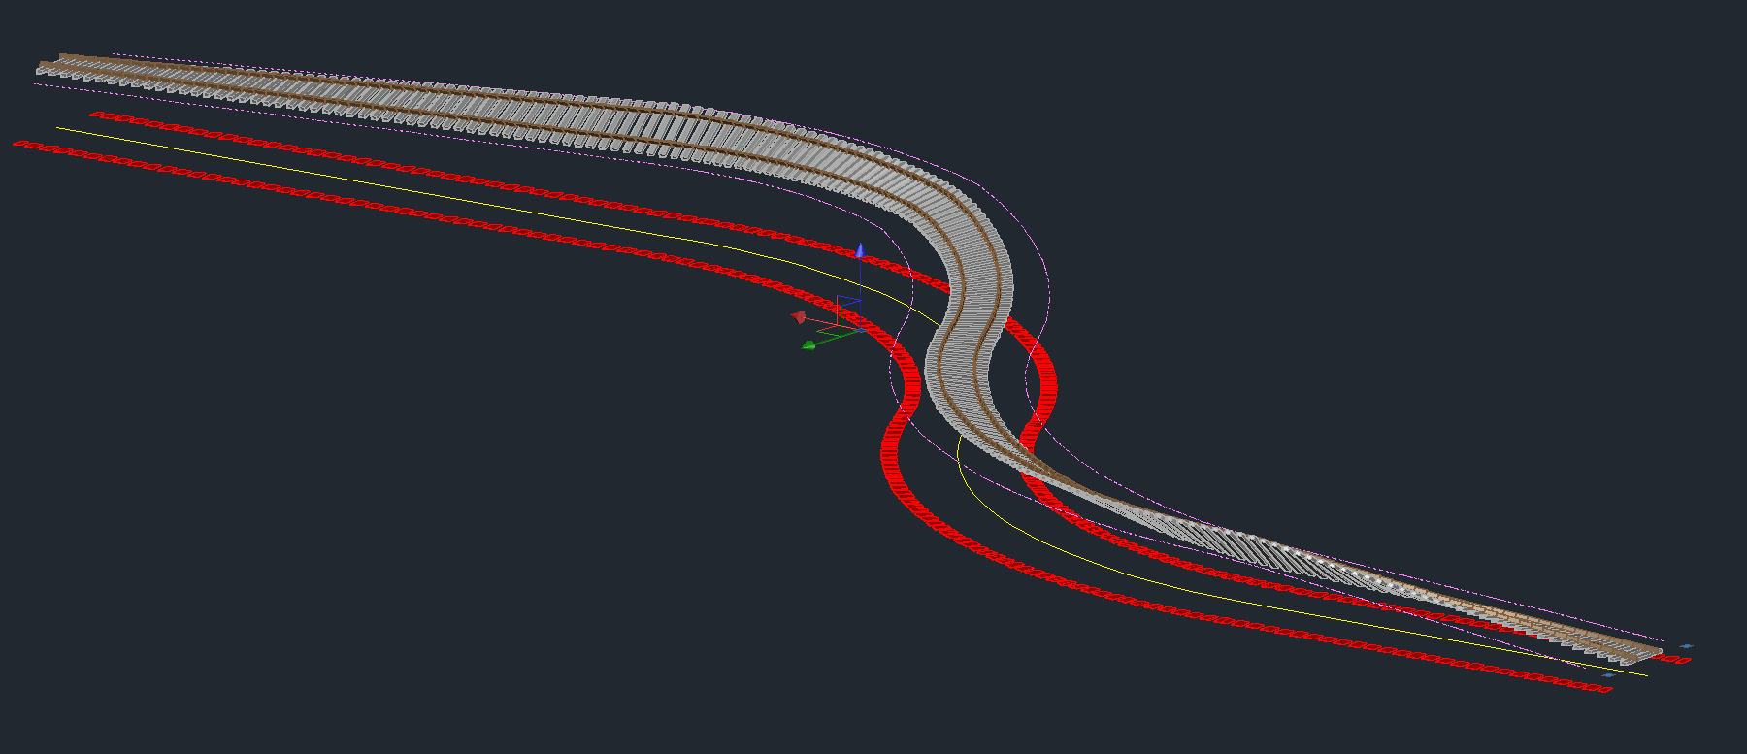
5. If you checked also the “Alignment axis” box in the Alignment Manager, the Alignment tab, then you will see one more line, not taking cant effects (or any other 3D formula) into consideration:   
     
   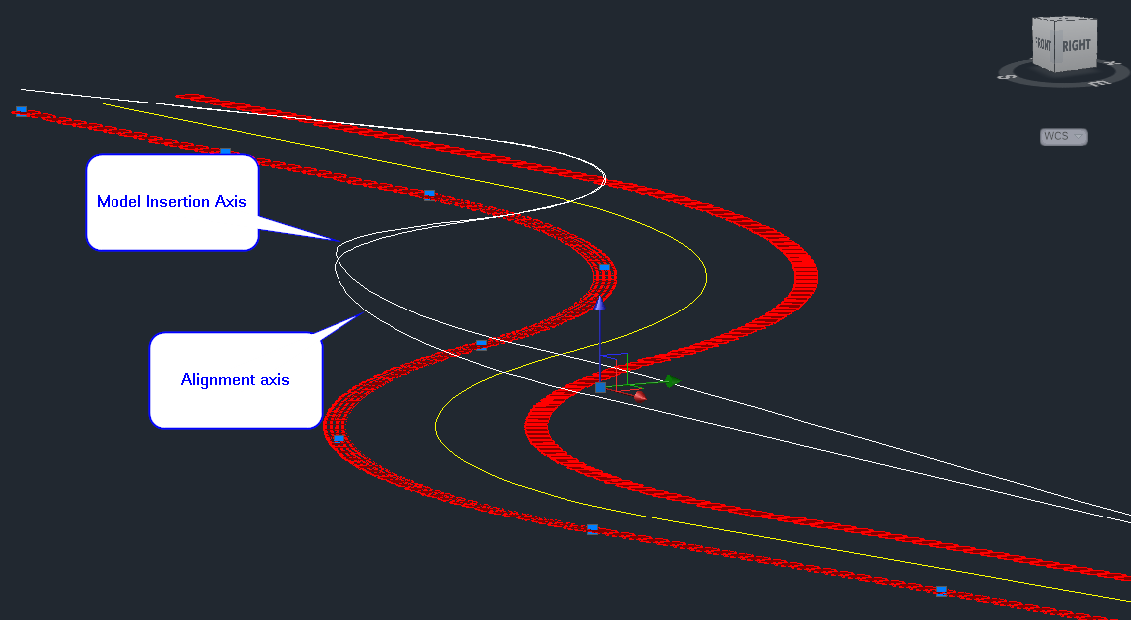
6. The model insertion axis corresponds to the line in space described by the cable duct elements’ insertion points during 3D export, which includes all effects of formulas on Offset3D and Rotation3D.
7. You can now EXPLODE (CAD system command) each model insertion axis in turn. This leaves a lot of straight-line segments in 3D space, one per modeled concrete cable duct element. Select those segments and use JOIN (CAD system command) to combine the straight-line segments into one 3D Polyline CAD entity.   
     
   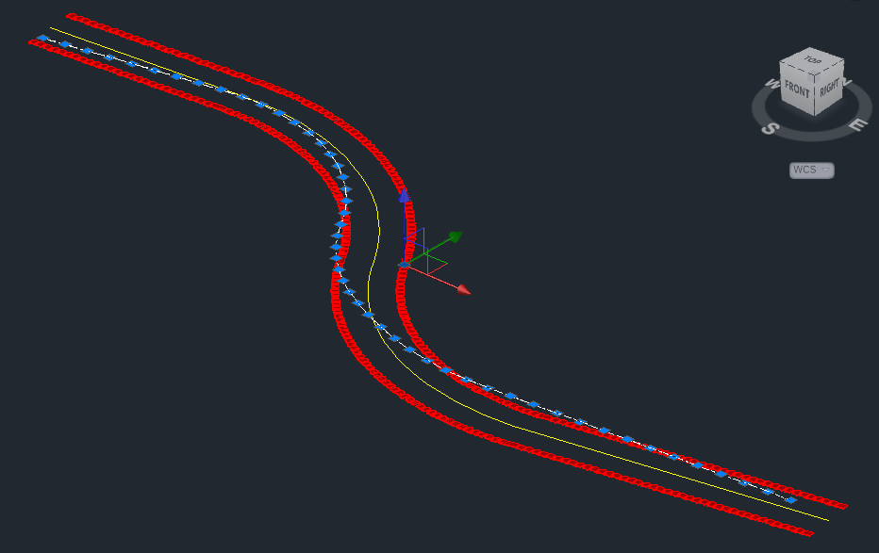
8. The 3D Polyline can now be saved as DWG or exported to IFC (if available).

## Export survey line to LandXML

1. Start RC-CreateAlignment and select any type of alignment object, for instance “Cable duct” (Kabelkanal) again. Press the down-arrow and select the ‘Polyline’ option, then select the 3D polyline we just produced. Alternatively, select the 3D polyline first, then start RC-CreateAlignment.  
     
   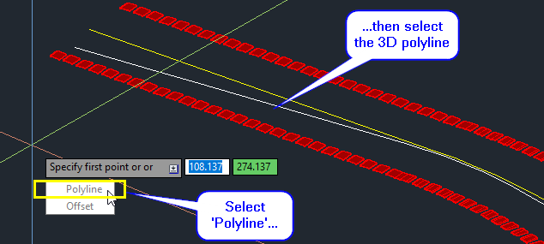  
     
   This has the effect of generating a new RailCOMPLETE alignment of type ‘cable duct’, with the old alignment’s model insertion axis as the new alignment’s alignment axis (and no cant data any longer, since plain 3D polylines don’t have cant). The former’s cant has been incorporated in the latter’s profile (Z coordinate) alignment axis data.  
     
   The new duct alignment has lots of rows in its horizontal geometry and vertical profile:  
     
   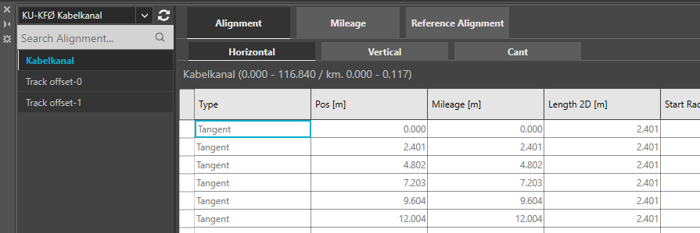  
     
   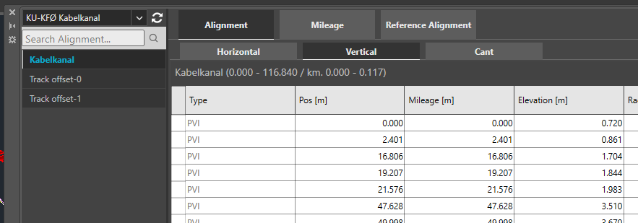
2. Open the Import/Export ribbon button again and start the RC-ExportAlignmentsToLandXml command.   
   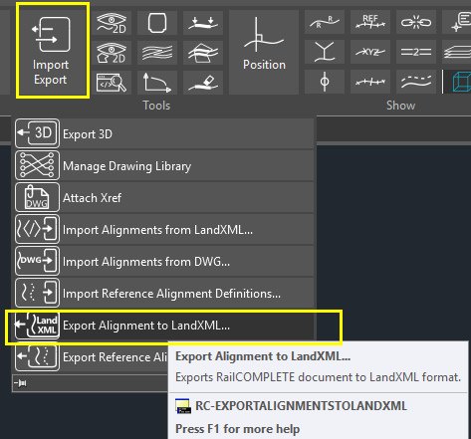
3. Deselect all alignments, then select just the recently produced survey line alignment, and export it to LandXML:  
     
   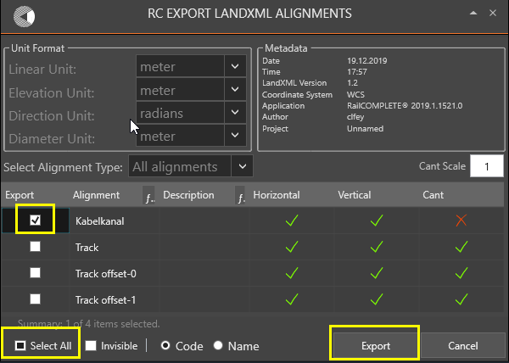

## Looking behind the curtains – the formulas placing the cable duct elements in 3D

1. Cable ducts use so-called *sampled formulas* in order to add variations to the offset and rotation of the individual cable duct elements along the alignment. Consult other tutorials to learn more about sampled formulas.
2. The cable duct element has been modelled with four geometric formulas which vary over the length of the duct’s alignment.
3. **Offset3D.Z**: Cable ducts are placed with the centre bottom of the duct element (usually a concrete or a plastic prefabricated element) on the duct’s alignment axis, in the absence of other factors. But if the cable duct is supposed to follow the extra elevation of the closest rail, then we will add an offset in the Z direction being the same as the extra elevation that the closest rail has received. To inspect or alter the formula using the Lua editor, start RC-ManageProperties and open the 3D tab, then open up the ‘3D Offset’ category, click the ‘Z’ row and press F3:  
     
   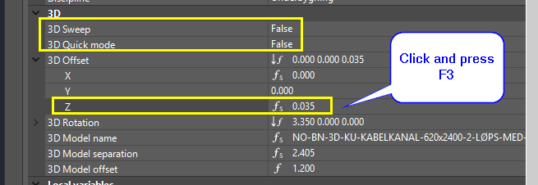  
     
   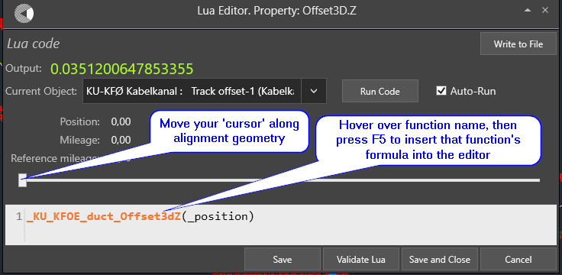
4. Clearly, the Offset3D.Z property calls a predefined function which does all the geometry for us. If you hover over the function’s name (and it is defined in the DNA of the present DWG model file), then its Lua code will be inserted as a version of that function, private to just this alignment:  
     
   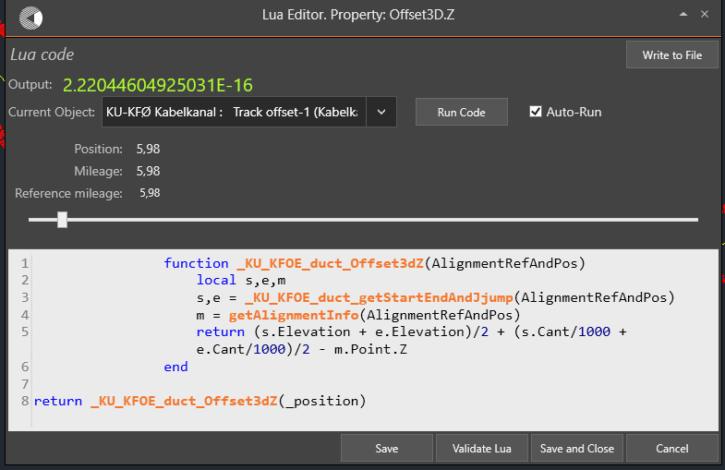  
     
   Note the use of the intrinsic (predefined in RailCOMPLETE) variable ‘**_position**’. It acts as a kind of “cursor” which slides from position zero to position Length2D, i.e. from start to end of the alignment as it has been laid out in the XY plane (the geometry).
5. You can now inspect the other formulas – Offset3D.X, Rotation3D.X and Rotation3D.Z. The principle in use is to find the start and end point of a duct element and to orient the 3D model accordingly.
6. We hope that you have now developed a sense of understanding for the Offset function and how to play with cant as extra elevation through the use of suitable formulas. We have also covered how to extract profile data which incorporates the effect of extra elevation.

Please check our website www.railcomplete.com for updates.

Corrections and suggestions are welcome to support@railcomplete.no.

Thank you for using RC Tutorials!

1. Your AutoCAD session has probably been started from a Windows shortcut of the type:  
   “C:\Program Files\Autodesk\AutoCAD 2019\acad.exe” /product ACAD /language “fr-FR” or similar (“fr-FR” means “French language, France’s version). Native AutoCAD commands may have different names in your language pack, other than the COPY, COPYBASE, FIND etc that you see in our tutorial texts. In order to instruct AutoCAD to accept the native English command name, precede the native (English) command name by an underscore character, ‘_’. For instance: ‘_FIND’ will start AutoCAD’s native ‘FIND’ command even if you are using AutoCAD with the French language pack, where the command in French is called ‘RECHERCHER’.If a command needs an argument ‘ON’, and the French menu says ‘Allumer’, then you can enter ‘_ON’ to instruct AutoCAD to use the option’s native name.